13.13: With the same value for , Eq. (13.19) gives 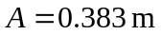and Eq. (13.18) gives
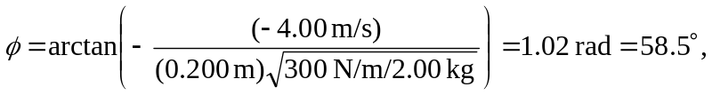

and x = (0.383 m) cos ((12.2 rad/s)t + 1.02 rad).

